SEC Form 3
FORM 3 | UNITED STATES SECURITIES AND EXCHANGE COMMISSION
 | Washington, D.C. 20549
 | Washington, D.C. 20549 |  | OMB APPROVAL
 | INITIAL STATEMENT OF BENEFICIAL OWNERSHIP OF SECURITIES
 | INITIAL STATEMENT OF BENEFICIAL OWNERSHIP OF SECURITIES |  | OMB Number: | 3235-0104
 |  |  | Estimated average burden
 | Filed pursuant to Section 16(a) of the Securities Exchange Act of 1934 |  | hours per response: | 0.5
or Section 30(h) of the Investment Company Act of 1940
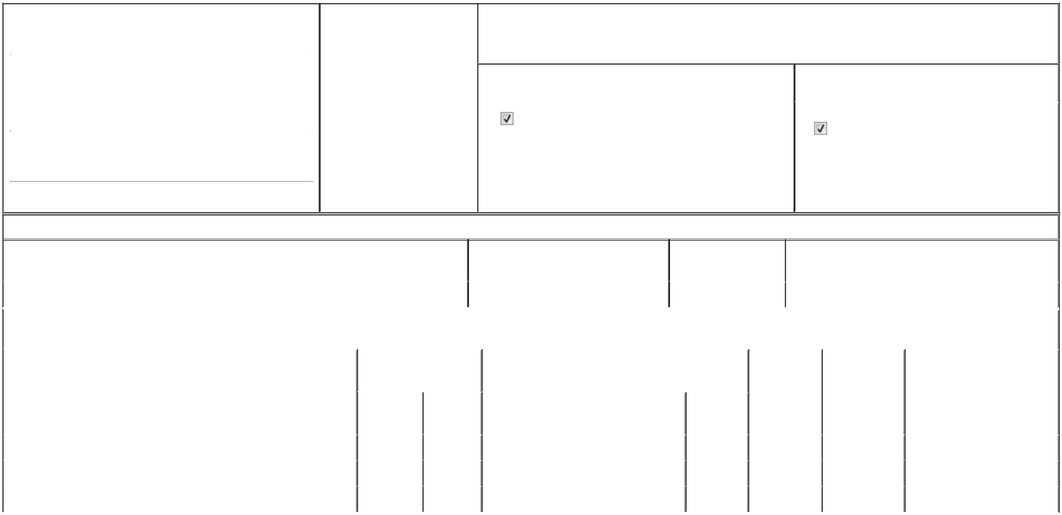

1. Name and Address of Reporting Person* |  |  |  |  |  | 2. Date of Event Requiring
 |  | Hansman Brad W. |  |  |  | Statement (Month/Day/Year)
 |  |  |  |  | 06/01/2026
 |  | (Last) | (First) |  | (Middle)
 |  | C/O MEDPACE HOLDINGS, INC.
 |  | 5375 MEDPACE WAY
(Street)
 |  | CINCINNATI | OH |  | 45227

3. Issuer Name and Ticker or Trading Symbol

Medpace Holdings, Inc. [ MEDP ]

4. Relationship of Reporting Person(s) to Issuer |  |  | 5. | If Amendment, Date of Original Filed (Month/Day/Year)
(Check all applicable)
Director |  | 10% Owner
Officer (give title |  | Other (specify below) | 6. | Individual or Joint/Group Filing (Check Applicable Line)
below) |  | Other (specify below) |  | Form filed by One Reporting Person
 | Exec. VP, Operations |  |  | Form filed by One Reporting Person
 |  |  |  | Form filed by More than One Reporting Person

(City) (State) (Zip)

Table I - Non-Derivative Securities Beneficially Owned

1. Title of Security (Instr. 4) | 2. Amount of Securities Beneficially | 3. Ownership Form: | 4. Nature of Indirect Beneficial Ownership (Instr. 5)
 | Owned (Instr. 4) | Direct (D) or Indirect
 |  | (I) (Instr. 5)

 | Common Stock |  |  |  | 697 | D
 |  |  | Table II - Derivative Securities Beneficially Owned
 |  | (e.g., puts, calls, warrants, options, convertible securities)
 | 1. Title of Derivative Security (Instr. 4) |  | 2. Date Exercisable and |  | 3. Title and Amount of Securities Underlying |  | 4. | 5. Ownership | 6. Nature of Indirect Beneficial
 |  |  | Expiration Date |  | Derivative Security (Instr. 4) |  | Conversion | Form: Direct | Ownership (Instr. 5)
 |  |  | (Month/Day/Year) |  |  |  | or Exercise | (D) or Indirect
 |  |  |  |  |  |  | Price of | (I) (Instr. 5)
 |  |  |  |  |  | Amount or | Price of | (I) (Instr. 5)
 |  |  |  |  |  | Amount or | Derivative
 |  |  | Date | Expiration | Title | Number of | Security
 |  |  | Exercisable | Date | Title | Shares
 | Restricted Stock Unit | (1) |  | (1) | Common Stock | 500 | (2) | D
 | Restricted Stock Unit | (3) |  | (3) | Common Stock | 5,000 | (2) | D
 | Employee Stock Option (Right to Buy) | (4) |  | 04/24/2033 | Common Stock | 10,000 | 410.54 | D
 | Explanation of Responses:

1. The restricted stock units vest in full on August 5, 2029, subject to the Reporting Person's continued employment with the Issuer or one of its subsidiaries.

2. Each restricted stock unit represents a contingent right to receive one share of MEDP common stock.

3. The restricted stock units vest in full on April 24, 2031, subject to the Reporting Person's continued employment with the Issuer or one of its subsidiaries.

4. The option vests in full on April 24, 2031, subject to the Reporting Person's continued employment with the Issuer or one of its subsidiaries.

Remarks:

Exhibit List: Exhibit 24 - Power of Attorney

 | /s/ Stephen P. Ewald, Attorney-in-Fact |  |  | 06/04/2026
 | for Brad W. Hansman
 | ** Signature of Reporting Person |  |  | Date
Reminder: Report on a separate line for each class of securities beneficially owned directly or indirectly.
* If the form is filed by more than one reporting person, see Instruction 5 (b)(v).
** Intentional misstatements or omissions of facts constitute Federal Criminal Violations See 18 U.S.C. 1001 and 15 U.S.C. 78ff(a).
Note: File three copies of this Form, one of which must be manually signed. If space is insufficient, see Instruction 6 for procedure.
Persons who respond to the collection of information contained in this form are not required to respond unless the form displays a currently valid OMB Number.



