United States

Securities and Exchange Commission
Washington, D.C. 20549

SCHEDULE 13D

(Rule 13d-101)

Information to be Included in Statements Filed Pursuant to § 240.13d-1(a) and

Amendments Thereto Filed Pursuant to § 240.13d-2(a)

Under the Securities Exchange Act of 1934

(Amendment No. 1)*

Medpace Holdings, Inc.

(Name of Issuer)

Common Stock

(Title of Class of Securities)

58506Q109

(CUSIP Number)

Dr. August J. Troendle

c/o Medpace Holdings, Inc.

5375 Medpace Way

Cincinnati, OH 45227

Tel: (513) 579-9911

(Name, Address and Telephone Number of Person Authorized to Receive Notices and Communications)

August 2, 2018

(Date of Event which Requires Filing of this Statement)

If the filing person has previously filed a statement on Schedule 13G to report the acquisition that is the subject of this Schedule 13D, and is filing this schedule because of §§ 240.13d-1(e), 240.13d-1(f) or 240.13d-1(g), check the following box. ☐

Note: Schedules filed in paper format shall include a signed original and five copies of the schedule, including all exhibits. See § 240.13d-7 for other parties to whom copies are to be sent.

- The remainder of this cover page shall be filled out for a reporting person’s initial filing on this form with respect to the subject class of securities, and for any subsequent amendment containing information which would alter disclosures provided in a prior cover page.

The information required on the remainder of this cover page shall not be deemed to be “filed” for the purpose of Section 18 of the Securities Exchange Act of 1934 (“Act”) or otherwise subject to the liabilities of that section of the Act but shall be subject to all other provisions of the Act (however, see the Notes).

1 |  | NAMES OF REPORTING PERSONS
 |  | August J. Troendle
2 |  | CHECK THE APPROPRIATE BOX IF A MEMBER OF A GROUP
 |  | (a) ☐ |  | (b) ☒
3 |  | SEC USE ONLY
4 |  | SOURCE OF FUNDS
 |  | PF
5 |  | Check if disclosure of legal proceedings is required pursuant to Items 2(d) or 2(e)
 |  | ☐
6 |  | CITIZENSHIP OR PLACE OF ORGANIZATION
 |  | United States
 |  |  |  | 7 | SOLE VOTING POWER
NUMBER OF |  |  |  |  | 489,956
 | SHARES
 |  |  |  | 8 | SHARED VOTING POWER
BENEFICIALLY |  |  |  | 8 | SHARED VOTING POWER
OWNED BY |  |  |  |  | 9,145,510
 | EACH |  |  |  | 9,145,510
 |  |  |  | 9 | SOLE DISPOSITIVE POWER
REPORTING |  |  |  | 9 | SOLE DISPOSITIVE POWER
 | PERSON |  |  |  | 489,956
 | WITH |  |  |  | 489,956
 |  |  |  | 10 | SHARED DISPOSITIVE POWER
 |  |  |  |  | 9,145,510
11 |  | AGGREGATE |  |  | AMOUNT BENEFICIALLY OWNED BY EACH REPORTING PERSON
 |  | 9,635,466
12 |  | CHECK IF THE AGGREGATE AMOUNT IN ROW (11) EXCLUDES CERTAIN SHARES
 |  | ☐
13 |  | PERCENT OF CLASS REPRESENTED BY AMOUNT IN ROW (11)
 |  | 27.1%
14 |  | TYPE OF REPORTING PERSON
 |  | IN
1 |  | NAMES OF REPORTING PERSONS
 |  | Medpace Investors, LLC
2 |  | CHECK THE APPROPRIATE BOX IF A MEMBER OF A GROUP
 |  | (a) ☐ |  | (b) ☒
3 |  | SEC USE ONLY
4 |  | SOURCE OF FUNDS
 |  | OO
5 |  | Check if disclosure of legal proceedings is required pursuant to Items 2(d) or 2(e)
 |  | ☐
6 |  | CITIZENSHIP OR PLACE OF ORGANIZATION
 |  | Delaware
 |  |  |  | 7 | SOLE VOTING POWER
NUMBER OF |  |  |  |  | 0
 | SHARES
 |  |  |  | 8 | SHARED VOTING POWER
BENEFICIALLY |  |  |  | 8 | SHARED VOTING POWER
OWNED BY |  |  |  |  | 9,145,510
 | EACH |  |  |  | 9,145,510
 |  |  |  | 9 | SOLE DISPOSITIVE POWER
REPORTING |  |  |  | 9 | SOLE DISPOSITIVE POWER
 | PERSON |  |  |  | 0
 | WITH |  |  |  | 0
 |  |  |  | 10 | SHARED DISPOSITIVE POWER
 |  |  |  |  | 9,145,510
11 |  | AGGREGATE |  |  | AMOUNT BENEFICIALLY OWNED BY EACH REPORTING PERSON
 |  | 9,145,510
12 |  | CHECK IF THE AGGREGATE AMOUNT IN ROW (11) EXCLUDES CERTAIN SHARES
 |  | ☐
13 |  | PERCENT OF CLASS REPRESENTED BY AMOUNT IN ROW (11)
 |  | 25.7%
14 |  | TYPE OF REPORTING PERSON
 |  | OO (Limited liability company)
This Amendment No. 1 to the Schedule 13D (this “Amendment No. 1”) amends and supplements the Statement on Schedule 13D filed with the United States Securities and Exchange Commission on August 26, 2016, (the “Statement”), relating to the common stock (the “Common Stock”), of Medpace Holdings, Inc., a Delaware corporation (the “Issuer”). Capitalized terms used herein without definition shall have the meaning set forth in the Statement.

Item 2.

Item 2 of the Statement is amended and restated in its entirety as follows:

This statement is being filed by Dr. August J. Troendle, a United States citizen (“Dr. Troendle”), and Medpace Investors, LLC (“MPI” and, together with Dr. Troendle, the “Reporting Persons”). Dr. Troendle is the sole manager of MPI.

The principal business address of each of the Reporting Persons is c/o Medpace Holdings, Inc., 5375 Medpace Way, Cincinnati, OH 45227.

Dr. Troendle’s principal occupation is serving as President, Chief Executive Officer and Chairman of the Board of Directors of the Issuer (the “Board”).

MPI is principally engaged in the investment of securities of the Issuer.

Shares beneficially owned by certain investment funds affiliated with Cinven Capital Management (the “Cinven Entities”) and held of record by Medpace Limited Partnership (“Medpace LP”) are not the subject of this Schedule 13D and the Cinven Entities and Medpace LP are accordingly not included as Reporting Persons. The board of directors of one of the Cinven Entities has voting and investment discretion with respect to shares held of record by Medpace LP. For a description of the relationship between the Cinven Entities and Dr. Troendle, see Item 4 of the Statement.

During the last five years, none of the Reporting Persons or Related Persons (i) has been convicted in any criminal proceeding (excluding traffic violations or similar misdemeanors) or (ii) was a party to a civil proceeding of a judicial or administrative body of competent jurisdiction and as a result of such proceeding was or is subject to a judgment, decree or final order enjoining future violations of, or prohibiting or mandating activities subject to, federal or state securities laws or finding any violation with respect to such laws.

Item 4. Purpose of Transaction

Item 4 of the Statement is amended and supplemented by inserting the following information:

The responses to Items 5 and 6 of this Schedule 13D are incorporated herein by reference.

On June 14, 2018, Dr. Troendle, as the Trustee of the August J. Troendle Revocable Trust (the “Trust”), entered into a written stock selling plan in accordance with Rule 10b5-1 (the “Plan”). The Trust holds a certain number of shares of Common Stock for the benefit of Dr. Troendle. Pursuant to the Plan, the Trust may sell up to an aggregate of 869,565 shares of Common Stock, subject to market conditions and the pricing parameters specified in the Plan. The Plan is scheduled to terminate June 15, 2019 or such earlier date as set forth in the Plan.

Dr. Troendle expects to use the proceeds from the sale of shares of Common Stock under the Plan to invest into the opportunity zone fund for the development of a new office tower for the Company at the Medpace Headquarters campus in Cincinnati, Ohio.

Item 5. Interest in Securities of the Issuer

Item 5 of the Statement is amended and restated in its entirety as follows:

(a) - (b)

The following sets forth the aggregate number and percentage of shares of Common Stock beneficially owned by each of the Reporting Persons, as well as the number of shares of Common Stock as to which each Reporting Person has the sole power to vote or to direct the vote, shared power to vote or to direct the vote, sole power to dispose or to direct the disposition, or shared power to dispose or to direct the disposition of as of the date of this filing, based on 35,555,874 shares of Common Stock outstanding as of July 27, 2018.

 |  |  |  |  |  |  | Sole power | Shared
 |  |  |  |  |  | Shared | Sole power | power to
 |  |  |  |  | Sole power | Shared | to dispose | dispose or
 |  |  | Amount | Percent | Sole power | power to | or to direct | to direct
 |  |  | Amount | Percent | to vote or | vote or to | the | the
Reporting Person(1) |  |  | beneficially | of | to direct | direct the | disposition | disposition
 |  |  | owned | Class | the vote | vote | of | of
 | Dr. August J. Troendle |  | 9,635,466 | 27.1% | 489,956 | 9,145,510 | 489,956 | 9,145,510
 | Medpace Investors, LLC |  | 9,145,510 | 25.7% | 0 | 9,145,510 | 0 | 9,145,510

- As discussed in Item 2 of the Statement and Item 2 of this Schedule 13D, the Cinven Entities (as defined in the Statement) and Medpace LP are not included as Reporting Persons in this Schedule 13D, and the Reporting Persons expressly disclaim beneficial ownership of the shares of Common Stock held by the Cinven Entities. Additionally, Dr. Troendle’s son purchased 10,000 shares of Common Stock on August 18, 2016, and the Reporting Persons expressly disclaim beneficial ownership of such shares.

As of August 7, 2018, MPI is the beneficial holder of 9,145,510 shares of Common Stock and the Trust is the beneficial holder of 489,956 shares of Common Stock. Dr. Troendle is the sole trustee, sole beneficiary and settlor of the Trust. Dr. Troendle is the sole manager of, and has the power to vote and dispose the securities held by, MPI and in such capacity may be deemed to share beneficial ownership of the shares of Common Stock owned by MPI.

Except as set forth in this Item 5(a)-(b), each of the persons named in this Item 5(a)-(b) disclaims beneficial ownership of any shares of Common Stock owned beneficially or of record by any other person named in this Item 5(a)-(b).

(c) Dr. Troendle sold 731,460 shares in open market transactions under the Plan, as follows:

Trade Date |  | Shares Sold |  | Price Per
 |  |  |  |  |  | Share
 | 8/2/2018 |  | 95,529 |  | $ | 58.43 | (1)
 | 8/2/2018 | 206,037 |  | $ |  | 59.26(2)
 | 8/2/2018 | 70,229 |  | $ |  | 60.09(3)
 | 8/3/2018 | 70,104 |  | $ |  | 59.39(4)
 | 8/3/2018 | 126,828 |  | $ |  | 60.19(5)
 | 8/3/2018 | 6,364 |  | $ |  | 60.95(6)
 | 8/6/2018 | 140,443 |  | $ |  | 58.45(7)
 | 8/6/2018 | 15,926 |  | $ |  | 59.06(8)

- The reported price is a weighted average price. These shares were sold in multiple transactions at prices ranging from $57.81 to $58.81. The Reporting Person undertakes to provide full pricing information to the Issuer, any security holder of the Issuer, or the staff of the Securities and Exchange Commission upon request.
- The reported price is a weighted average price. These shares were sold in multiple transactions at prices ranging from $58.82 to $59.82. The Reporting Person undertakes to provide full pricing information to the Issuer, any security holder of the Issuer, or the staff of the Securities and Exchange Commission upon request.

- The reported price is a weighted average price. These shares were sold in multiple transactions at prices ranging from $59.83 to $60.75. The Reporting Person undertakes to provide full pricing information to the Issuer, any security holder of the Issuer, or the staff of the Securities and Exchange Commission upon request.

- The reported price is a weighted average price. These shares were sold in multiple transactions at prices ranging from $58.87 to $59.87. The Reporting Person undertakes to provide full pricing information to the Issuer, any security holder of the Issuer, or the staff of the Securities and Exchange Commission upon request.

- The reported price is a weighted average price. These shares were sold in multiple transactions at prices ranging from $59.87 to $60.88. The Reporting Person undertakes to provide full pricing information to the Issuer, any security holder of the Issuer, or the staff of the Securities and Exchange Commission upon request.

- The reported price is a weighted average price. These shares were sold in multiple transactions at prices ranging from $60.89 to $61.02. The Reporting Person undertakes to provide full pricing information to the Issuer, any security holder of the Issuer, or the staff of the Securities and Exchange Commission upon request.

- The reported price is a weighted average price. These shares were sold in multiple transactions at prices ranging from $57.84 to $58.84. The Reporting Person undertakes to provide full pricing information to the Issuer, any security holder of the Issuer, or the staff of the Securities and Exchange Commission upon request.

- The reported price is a weighted average price. These shares were sold in multiple transactions at prices ranging from $58.85 to $59.59. The Reporting Person undertakes to provide full pricing information to the Issuer, any security holder of the Issuer, or the staff of the Securities and Exchange Commission upon request.

- None.

- Not Applicable.

Item 6. Contracts, Arrangements, Understandings or Relationships With Respect to Securities of the Issuer

Item 6 of the Statement is amended and supplemented as follows:

Item 4 above summarizes certain provisions of the Plan and is incorporated herein by reference. A copy of the Plan is attached as Exhibit 5 hereto, and is incorporated by reference.

Except as set forth herein and the Statement, none of the Reporting Persons or Related Persons has any contracts, arrangements, understandings or relationships (legal or otherwise) with any person with respect to any securities of the Issuer, including, but not limited to, any contracts, arrangements, understandings or relationships concerning the transfer or voting of such securities, finder’s fees, joint ventures, loan or option arrangements, puts or calls, guarantees of profits, division of profits or losses, or the giving or withholding of proxies.

Item 7. | Materials to be Filed as Exhibits
Exhibit | Description
Number | Description
- Joint Filing Agreement*

- Voting Agreement*

- Registration Rights Agreement*

- Form of Lock-Up Agreement*

- Rule 10b5-1 Stock Trading Plan of the August J. Troendle Revocable Trust dated June 14, 2018 * Filed in the Statement.

SIGNATURES

After reasonable inquiry and to the best of my knowledge and belief, I certify that the information set forth in this statement is true, complete and correct.

Date: August 8, 2018

/s/ Dr. August J. Troendle

Dr. August J. Troendle

Medpace Investors, LLC

/s/ Dr. August J. Troendle

Name: Dr. August J. Troendle

Title: Sole Manager

Exhibit 5
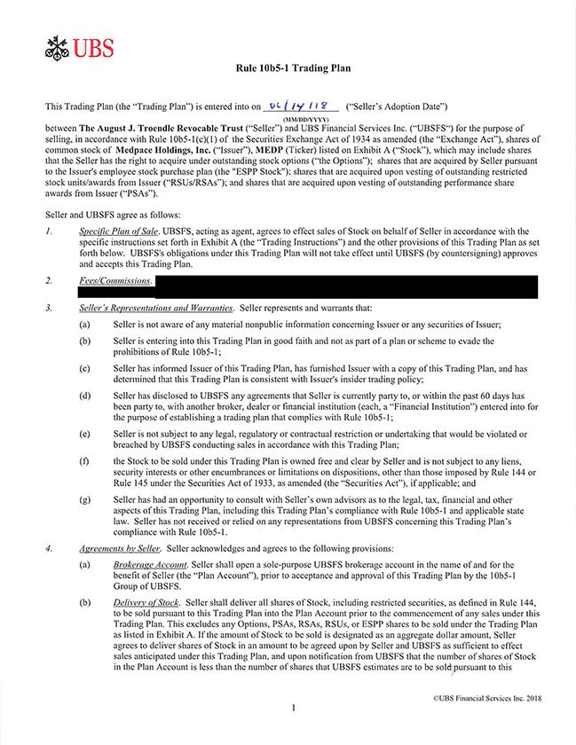

Rule 10b5-1 Trading Plan | Trading Plan (the “Trading Plan”) is entered into on 06/14/18 (“Seller’s Adoption Date”) (MM/DD/YYYY) between The August J. Troendle Revocable Trust (“Seller”)
and UBS Financial Servi | ThisInc. (“UBSFS“) for the purpose of selling, in accordance with Rule 10b5- 1(c)(1) of the Securities Exchange Act of 1934 as amended (the “Exchange Act”), shares of
common stock of Medpace Holdings, Inc. (“Issuer”), MEDP (Ticker) listed on Exhibit A (“Stock”), which may include shares that the Seller has the right to acquire under outstanding stock options (“the
Options”); shares that are acquired by Seller pursuant to the Issuer’ |  | employee stock purchase plan (the “ESPP Stock”); shares that are acquired upon vesting of outstanding restricted stock units/awards
from Issuer (“RSUs/RSAs”); and shares that are acquired upon vesting of |  |  | performance share awards from Issuer (“PSAs”). Seller and UBSFS agree as follows: /. Specific Plan of Sale.
UBSFS, acting as agent, agrees to effect sales of Stock on behalf of Seller outstandingaccordance with the specific instructions set forth |  |  |  |  | Exhibit A (the “Trading Instructions”) and the other provisions of this
Trading Plan as set forth below. UBSFS’ obligations under this Trading Plan will not take effect until UBSFS (by countersigning) approves and accepts this Trading Plan. Seller’s Representations and
Warranties. Seller represents and warrants that: Seller is not aware of any material nonpublic information concerning Issuer or any securities of Issuer; Seller is entering into this Trading Plan good faith
and not as part of a plan or scheme to evade the prohibitions of Rule 10b5-1; Seller has informed Issuer of this Trading Plan, has furnished Issuer with a copy of this Trading Plan, and has determined |  |  |  |  |  | at
this Trading Plan is consistent with Issuer’s insider trading policy; Seller has disclosed to UBSFS any agreements that Seller is currently party to, or within the past 60 days has been party to, with another
b oker, dealer or financial institution (each, a “Financial Institution”) entered into for the purpose of |  |  |  | trading plan that complies with Rule 10b5-1; Seller is not subject to any legal, regulatory
or contractual restriction or undertaking that would be violated or breached by UBSFS conducting salesestablishingaccordance with this Trading Plan; the Stock to be sold under this Trading Plan is owned free
and clear by Seller and is not subject to any liens, security interests or other encumbrances or limitations on |  |  |  | other than those imposed by Rule 144 or Rule 145 under the Securities Act of
1933, as amended (the | Act”), if applicable; and Seller has had an opportunity to consult with Seller’ |  |  | own advisors as to the legal, tax, financial and other aspects of this Trading Plan,
including this Trading Plan’“Securitiescompliance with Rule 10b5-l and applicable state law. Seller has not received ordispositions,reliedany |  |  |  |  | from UBSFS concerning this Trading Plan’s compliance with
Rule 10b5- . Agreements by Seller. Seller acknowledges and agrees to the following provisions: Brokerage Account. Seller shallrepresentationsopensolc-purpose UBSFS brokerage account in the name of and for the
benefit of Seller (the “Plan Account”), prior to acceptance and approval of this Trading Plan by the 10b5-1 Group of UBSFS. Delivery of Stock. Seller shall deliver all shares of Stock, including restricted
securities, as defined in Rule 144, to be sold pursuant to this T |  | Plan into the Plan Account prior to the commencement of any sales under this Trading Plan. This excludes any Options, PSAs, RSAs,
RSUs, or ESPP shares to be sold under the Trading Plan as listedradingExhibit A. If the amount of Stock to be sold is designated as an aggregate dollar amount, Seller agrees to deliver shares of Stock in an amount to be agreed upon by Seller and UBSFS as sufficient to effect sales anticipated under this Trading Plan, and upon notification from UBSFS that the number of shares of Stock in the Plan Account is less than the number of shares that UBSFS estimates are to be sold pursuant to this

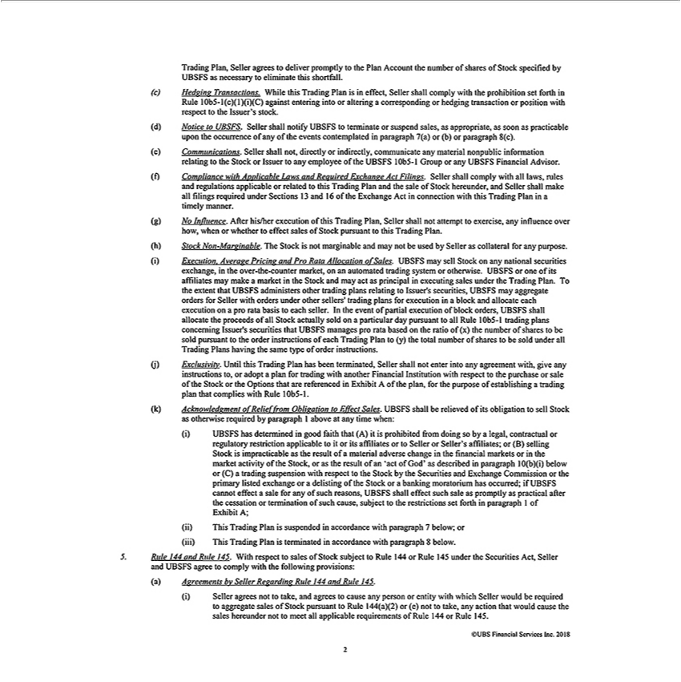

Trading Plan, Seller agrees to deliver promptly to the Plan Account the number of shares of Stock specified by UBSFS as |  |  |  |  | to eliminate this shortfall. Hedging Transactions. While this Trading
Plan is in effect, Seller shall comply with the prohibition set forth in Rule 10b5-l(c)(l)(i)(C) against entering into or alteringnecessarycorresponding or hedging transaction or position with respect to the Issuer’s
stock. Notice to UBSFS. Seller shall notify UBSFS to terminate or suspend sales, as appropriate, as soon as practicable upon the occurrence of any of the events contemplated in paragraph 7(a) or (b) or
paragraph 8(c). Communications. Seller shall not, directly or indirectly, communicate any material nonpublic information relating to the Stock or Issuer to any employee of the UBSFS 10b5-l Group or
y UBSFS Financial Advisor. Compliance with Applicable Laws and Required Exchange Act Filings. Seller shall comply with all laws, rules and regulations |  |  |  |  |  | or related to this Trading Plan
and the sale of Stock hereunder, and Seller shall make all filings required under Sections 13 and 16 of the Exchange Act in connection with this Trading Plan |  |  |  |  |  | applicabletimelymanner. | Influence. After
his/her execution of this Trading Plan, Seller shall not attempt to exercise, any influence over how, when or whether to effect sales of Stock pursuant to this Trading Plan. Stock Non-Marginable. The
Stock is not marginable and may not be used by Seller as collateral for any purpose. Execution. Average Pricing and Pro Rata |  |  |  |  | of Sales. UBSFS may sell Stock on any national securities
exchange, in the | -the-counter market, on an automated trading system or otherwise. UBSFS or one of its affiliates may makeAllocationmarket in the Stock and may act as principal in executing sales under
the Trading | .overTthe extent that UBSFS |  | other trading plans relating to Issuer’s securities, UBSFS may aggregate orders for Seller with orders under other sellers’ trading plans for
execution inPlanblock and |  | each executionadministersonpro rata basis to each seller. In the event of partial execution of block orders, UBSFS shall allocate the proceeds of all Stock actually sold on a
particular day pursuant toallocateRule 10b5-1 trading plans concerning Issuer’ securities that UBSFS manages pro rata based on the ratio of (x) the number of shares to be sold pursuant to the order
instructions of each Trading Plan to (y) the total number of shares to be sold under all Trading Plans having the same type of order instructions. (j) Exclusivity. Until this Trading Plan has been terminated,
Seller shall not enter into any agreement with, give any instructions to, or adopt a plan for trading with another Financial Institution with respect to the purchase or sale of the Stock or the Options that are
referenced in Exhibit A of the plan, for the purpose of establishing trading plan that complies with Rule 10b5-1. (k) Acknowledgment of Relief from Obligation to Effect Sales. UBSFS shall be relieved
of its obligation to sell Stock as otherwise required by paragraph 1 above at any time when: UBSFS has determined in good |  |  |  |  | that (A) it is prohibited from doing so by legal, contractual or regulatory
restriction applicable to it or its affiliates or to Seller or Seller’s affiliates; or (B) selling Stock is impracticable as the result offaithmaterial adverse change in the financial markets or in the market activity of
the Stock, or as the result of an ‘act of God’ |  |  | described in paragraph 10(b)(i) below or (C) a trading suspension with respect to the Stock by the Securities and Exchange Commission or the primary
listed exchange or delisting of the Stock oras banking moratorium has occurred; if UBSFS cannot effect a sale for any of such reasons, UBSFS shall effect such sale as promptly as practical after the
cessation or termination of such cause, subject to the restrictions set forth in paragraph 1 of Exhibit A; This Trading Plan is suspended in accordance with paragraph 7 below; or This Trading Plan is
erminated accordance with paragraph 8 below. Ride 144 and Rule 145. With respect to sales of |  |  |  | subject to Rule 144 or Rule 145 under the Securities Act, Seller and UBSFS agree to comply with
the following provisions: Agreements bv Seller Regarding Rule 144 and Rule 145. Seller agrees notStocktake, and agrees to cause any person or entity with which Seller would be required to aggregate sales of Stock pursuant to Rule 144(a)(2) or (e) not to take, any action that would cause the sales hereunder not to meet all applicable requirements of Rule 144 or Rule 145

Seller agrees to complete, execute and deliver to UBSFS, Forms 144 for sales to be effected under the Trading Plan at such times and in such numbers as UBSFS shall reasonably request. Seller hereby
grants UBSFS a power of |  | to complete and file on behalf of Seller any Forms 144 as required by applicable law, rule or regulation in order to sell Stock pursuant to this Trading Plan in accordance
with Rule 144. Seller agreesattorneycomplete, execute and deliver to UBSFS Rule 144 Seller’s Representation Letters (in the form attached as Exhibit C) for sales to be effected under the Trading Plan at such
times and in such numbers as UBSFS shall request. Seller agrees to notify he 10b5-1 Group of UBSFS immediately if there is any change in Seller’s employment, affiliate or non-affiliate status.
Agreements by UBSFS Regarding Rule 144 and Rule 145. UBSFS agrees to conduct all sales pursuant to the Trading Plan in accordance with the manner of sale requirement of Rule 144. UBSFS shall
not affect any sales that it knows would exceed the then-applicable volume limitation under Rule 144. UBSFS agrees to file such Forms 144 furnished by Seller pursuant to paragraph 5(a)(ii) on behalf of
Seller as required by applicable law. UBSFS agrees to submit such Rule 144 Seller’ Representation Letters furnished by Seller pursuant to paragraph 5(a)(iii) |  |  |  |  |  | behalf of Seller as required by Issuer’s
transfer agent. 6 Options. If applicable, Seller and UBSFS agree to the provisions r ga ding the |  |  | of Options contained in Exhibit A. Seller’ Representations and Warranties. Seller represents and
warrants that the Options listed in Exhibit A are held free and clear without liens, security interesexerciseorother encumbrances or limitations |  |  |  |  | exercise of the vested portion thereof, other than the |  | security
requirement that Seller comply with the exercise provisions of such Options; and The shares of |  |  | Stock acquired through exercise of the |  | shall be held free and clear by Seller without |  | security
interests or other encumbrances or limitations on disposition. Delivery. Seller agrees to complete, execute and deliver to UBSFS Stock OptionsExercise Notices in the form provided by Issuerliens,for the
exercise of | pursuant to the Trading Plan at such times and in such numbers as UBSFS shall reasonably request. Seller hereby authorizes UBSFS to deliver such Stock Option Exercise Notices to
Issuer on Seller’Optionsbehalf as necessary to effectuate such exercises and settle the sales of Stock underlying such Options under the Trading Plan. Seller agrees to make appropriate arrangements to ensure
that Stock received upon the exercise of Options shall be delivered to the Plan Account promptly after Issuer’s receipt of the applicable Stock Option Exercise Form. UBSFS shall be relieved of its
obligation to exercise Options and sell Stock as otherwise required at any time when Seller has failed to deliver |  |  |  | Options Exercise Notices or |  | Stock. Exercise. Putsuant to an appropriately
and fully completed Stock Option Exercise Notice received from Seller, UBSFS shall exercise Options necessaryStockeffect sales of underlying Stockunderlyingthemanner specified in Exhibit A. UBSFS shall, in connection with the exercise of Options, remit to Issuer the exercise price along with such amounts as may be necessary to satisfy withholding obligations. These amounts shall be deducted from the proceeds of sale of the Stock, together with late fees, if applicable. UBSFS shall in no event exercise any Option if, at the time of exercise, the cost of the Option exercise (plus fees and commissions) is equal to or greater than the market value of the Stock.

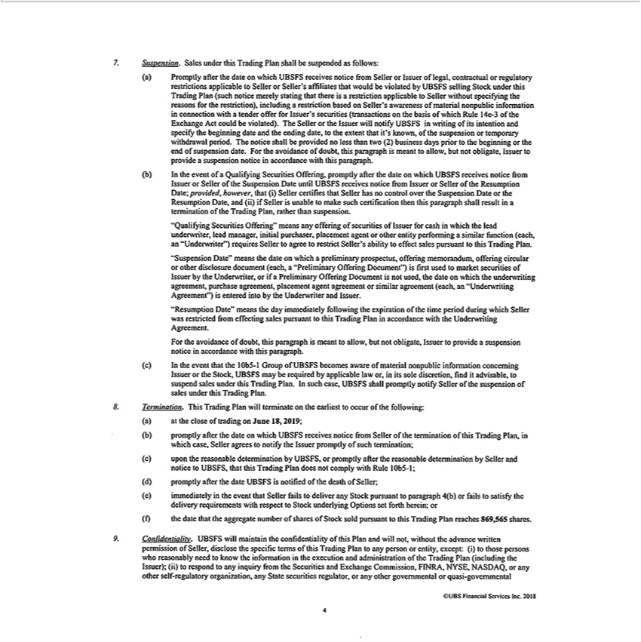

Suspension. Sales under this Trading Plan shall be suspended as follows: 7. Promptly after the date on which UBSFS receives notice from Seller or Issuer of legal, contractual or regulatory restrictions
applicable to Seller or Seller’ |  | affiliates | would be violated by UBSFS selling Stock under this Trading Plan (such notice merely |  |  |  | that there is a | applicable to Seller without specifying
the reasons for the restriction), includingthatrestriction based on Seller’s awareness of material nonpublic information in connection withstatingtender offer for Issuer’restrictionsecurities |  |  |  |  |  |  |  |  |  | on the basis of
which Rule 14e-3 of the Exchange Act could be violated). The Seller or the Issuer will |  |  |  |  |  | UBSFS in writing of its intention and specify the beginning date and the ending(transactionsdate,the extent that it’s
known, of the suspension or temporary withdrawal period. The notice shall be providednotifyless than two (2) business days prior to the beginning or the end of suspension date. For the avoidance of doubt,
this paragraph is meant to allow, but not obligate, Issuer to provide a suspension notice in accordance with this paragraph. In the event of a Qualifying Securities Offering, promptly after the date on which
UBSFS receives notice from Issuer or Seller of the Suspension Date until UBSFS receives notice from Issuer or Seller of the Resumption Date; provided, however, that (i) Seller certifies that Seller has no
control over the Suspension Date or the Resumption Date, and (ii) if Seller is unable to make such certification then this paragraph shall result in a termination of the Trading Plan, rather than suspension.
“Qualifying Securities Offering” means any offering of securities of Issuer for cash in which the lead underwriter, lead manager, initial purchaser, placement agent or other entity performing a similar
function (each, | “Underwriter”) requires Seller to agree to restrict Seller’s |  |  |  | to effect sales pursuant to this Trading Plan. “Suspension Date” means the date on which a |  |  |  |  | prospectus,
offering memorandum, offering circular or other disclosure document (each, ability“Preliminary Offering Document”) is first used to market securities of Issuer by the Underwriter,preliminaryorifPreliminary Offering
Document is not used, the date |  | which the underwriting agreement, purchase agreement, placement agent agreement or similar agreement (each, an “Underwriting Agreement”) is entered into by the
Underwriter and Issuer. “Resumption Date” means the day immediately following the expiration of the time period during which Seller was restricted from ef |  |  |  |  |  |  |  |  | sales pursuant to this Trading Plan in
accordance with the Underwriting Agreement. For the avoidance of doubt, this paragraph is meant to allow, but not obligate, Issuer to provide a suspension noticefecting |  |  |  |  |  |  |  |  |  | with this paragraph. In the
event that the 10b5-1 Group of UBSFS becomes aware of material nonpublic information concerning Issuer or the Stock, UBSFS may be required by applicable law accordance,initssole discretion, find it
advisable, to suspend sales under this Trading Plan. In such case, UBSFS shall promptly notify Seller of the suspension of sales under this Trading Plan. Termination. This Trading Plan will terminate on
the earliest to occur of the following: at the close of trading |  |  |  | June 18,2019; promptly after the date on which UBSFS receives notice from Seller of the termination of this Trading Plan, in which case,
Seller agrees to | the Issuer promptly of such termination; upon the reasonable determination by UBSFS, or promptly after the reasonable determination by Seller and notice to UBSFS, that this
Trading Plan doesnotify comply with Rule 10b5-1; promptly after the date UBSFS is notified of the death of Seller; immediately in the event that Seller fails |  |  |  |  |  |  |  | deliver any |  | pursuant to paragraph 4(b)
or fails to satisfy the delivery requirements with respect to Stock underlying Options set forth herein; or the date that the aggregate number of shares of Stock sold pursuantStockthis Trading Plan reaches 869,565 shares. Confidentiality. UBSFS will maintain the confidentiality of this Plan and will not, without the advance written permission of Seller, disclose the specific terms of this Trading Plan to any person_{Securities}orentity, except: (i) to those persons who reasonably need to know the information in the execution and administration of the Trading Plan (including the Issuer); (ii) to respond to any inquiry from

the and Exchange Commission, FINRA, NYSE, NASDAQ, or any other self-regulatory organization, any State securities regulator, or any other governmental or quasi-govemmental

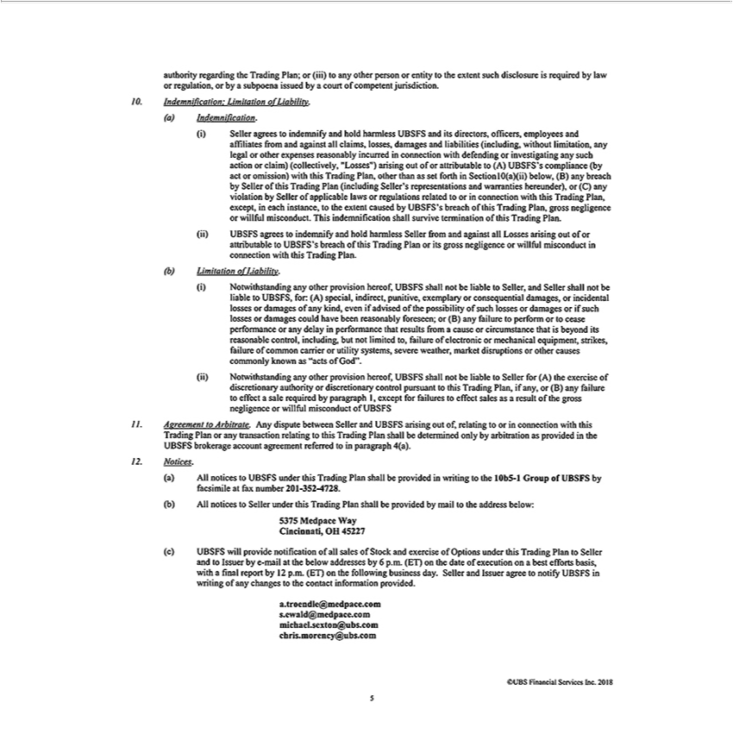

authority regarding the Trading Plan; or (iii) to any other person or entity to the extent such disclosure is required by law |  |  |  |  |  |  | regulation, or by a subpoena issued by a court of competent jurisdiction.
Indemnification: Limitation of Liability. Indemnification. Seller agrees to indemnify and hold harmless UBSFS and its directors, officers, employees and affiliates from and against all |  |  |  |  |  |  |  |  |  |  | losses,
damages and liabilities (including, without limitation, any legal or other expenses reasonably incurred in connection with |  |  |  |  |  |  |  | or investigating any such action or claim) (collectivelyclaims,“Losses”)
arising out of or attributable to (A) UBSFS’ |  |  | compliance (by act or omission) with this Trading Plan, other than as set forthdefendingSection 10(a)(ii) below, (B) any breach by Seller of this Trading Plan
(including Seller’s |  | and warranties hereunder), or (C) any violation by Seller of applicable laws or regulations related to or connection with this Trading Plan, except, in each instance, to
the extent caused byrepresentationsUBSFS’breach of this Trading Plan, gross negligence or willful |  |  |  |  |  | . This indemnification shall survive termination of this Trading Plan. UBSFS agrees to indemnify and
hold harmless Seller from | against all Losses arising out of or attributable to UBSFS’misconductbreachof this Trading Plan or its gross negligence or willful misconduct connection with this Trading Plan.
Limitation of Liability. Notwithstanding any other provision hereof, UBSFS shall not be liable to Seller, and Seller shall not be liable to UBSFS, |  |  |  |  |  |  |  |  | (A) special, indirect, punitive, exemplary
consequential damages, or incidental losses |  |  | damages of any | even if advised of the possibility of such losses or damages or if such losses for:damages could have been reasonably foreseen; or
(B) any failure to perform or to cease performance or any delaykind, |  |  |  | that results from |  | cause or circumstance that is beyond its reasonable control, including, but not limited to, failure of
electronic or mechanical equipment, strikes, failure of common carrierperformanceutility systems, severe weather, market disruptions or other causes commonly known as “acts of God”. |  |  |  |  |  |  |  |  |  |  | any other
provision hereof, UBSFS shall not be liable to Seller for (A) the xercise of discretionary authority or discretionary control pursuant to this Trading Plan, if any, or (B) any failureNotwithstandingtoeffectsale required
by paragraph 1, except for failures to effect sales as a result of the gross negligence or willful misconduct of UBSFS Agreement to Arbitrate. Any dispute between Seller and UBSFS arising out of,
to or in connection with this Trading Plan or any transaction relating to this Trading Plan shall be determined only by arbitration as provided in the UBSFS brokerage account agreement referred
relatingtoparagraph 4(a). Notices. All notices to UBSFS under this Trading Plan shall be provided |  |  |  |  |  | writing to the 10b5-1 Group of UBSFS by facsimile at fax number 201-352-4728. All notices to Seller
under this Trading Plan shall be |  | by mail to the address below: 5375 Medpace Way Cincinnati, OH 45227 UBSFS will provide |  |  |  |  |  |  | of all sales of Stock and exercise of Options under this
Trading Plan to Seller and to Issuerprovidedby-mail at the below addresses by 6 p.m. (ET) |  |  |  |  | the date of execution on best efforts |  |  | withnotificationfinalreport by 12 p. . (ET) |  | the following business day.
Seller and Issuer agree to notify UBSFS in writing of any changes to the contact information provided. a.troendle@medpace.combasis,.ewald@medpace.com michael.sexton@ubs.com
chris.morency@ubs.com

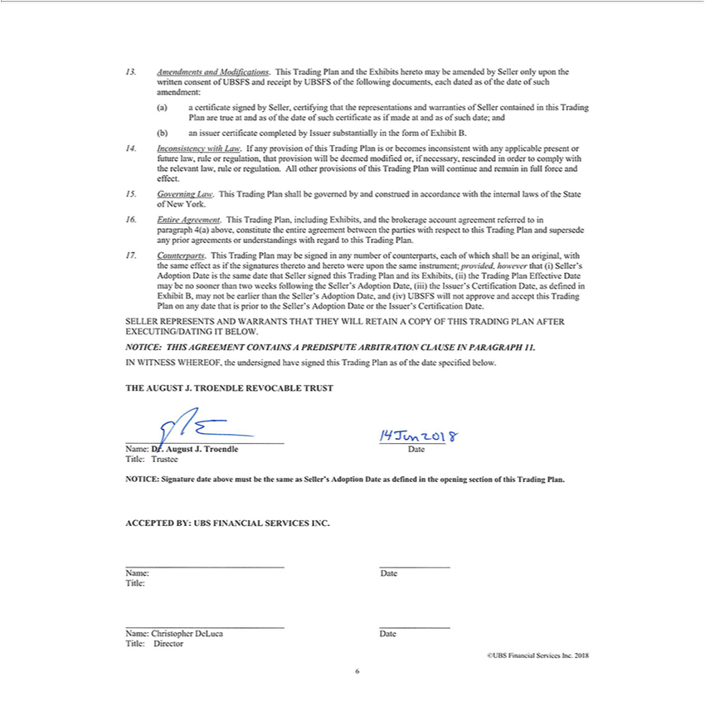

Amendments and Modifications. This T | Plan and the Exhibits hereto may be amended by Seller only upon the written consent of UBSFS and receipt by UBSFS of the following documents, each
dated as of the date of such amendment:radingcertificate igned by Seller, certifying that the representations and warranties of Seller contained in this Trading Plan are true at and as of the date of such
certificate as if made at and as of such date; and an issuer certificate completed by Issuer substantially in the form of Exhibit B. Inconsistency with Law. If any provision of this Trading Plan is or becomes
inconsistent with any applicable present or future law, rule or regulation, that provision will be deemed modified or, if neccssary, rescinded in order to comply with the relevant law, rule or regulation. All
other provisions of this Trading Plan will continue and remain full force and effect. Governing Law. This Trading Plan shall be governed by and construed in accordance with the internal laws of the
State of New York. Entire Agreement. This Trading Plan, including Exhibits, |  | the brokerage account agreement referred to in paragraph 4(a) above, constitute the entire agreement between the parties
with respect to this Trading Plan and supersede any prior agreements or |  | with regard to this Trading Plan. Counterparts. This Trading Plan may be signed in any number of counterparts,
each of which shall be an original, with the same effect as if the signaturesunderstandingstheretohereto were upon the same instrument; provided, however that (i) Seller’ |  |  |  | Adoption Date is the same date that Seller
signed this Trading Plan and its Exhibits, (ii) the Trading Plan Effective Date may be no sooner than two weeks following the Seller’s Adoption Date, (iii) the |  |  |  | ’s Certification Date, as defined in
Exhibit B, may not be earlier than the Seller’s Adoption Date, and (iv) UBSFS will not approve and accept this |  |  | rading Plan on any date that is prior to the Seller’IssuerAdoption Date or the Issuer’s
Certification Date. SELLER REPRESEN | AND WARRANTS THAT THEY WILL RETAIN A COPY OF THIS TRADING PLAN AFTER |  |  | TING IT BELOW. NOTICE: THIS A
GREEMENT CONTAINS A PREDISPUTE ARBITRA TION CLA USE IN PARA GRAPH 11. IN |  |  | WHEREOF, the undersigned haveEXECUTING/DAsignedthisrading Plan as of the date specified below.
WITNESS
definedTHEAUGUSTintheopeningJ.TROENDLEsectionofREVOCABLEthisTradingPlan.TRUSTACCEPTED14Jun2018BY: UBSName:FINANCIALDr.August SERVICESJ.Troendle INC.itle: Name:rusteeDateDateTitle:NOTICE:Name:SignatureChristopherdateDeLucaabovemustDatebeTitle:the sameDirectorasSeller’s Adoption Date as

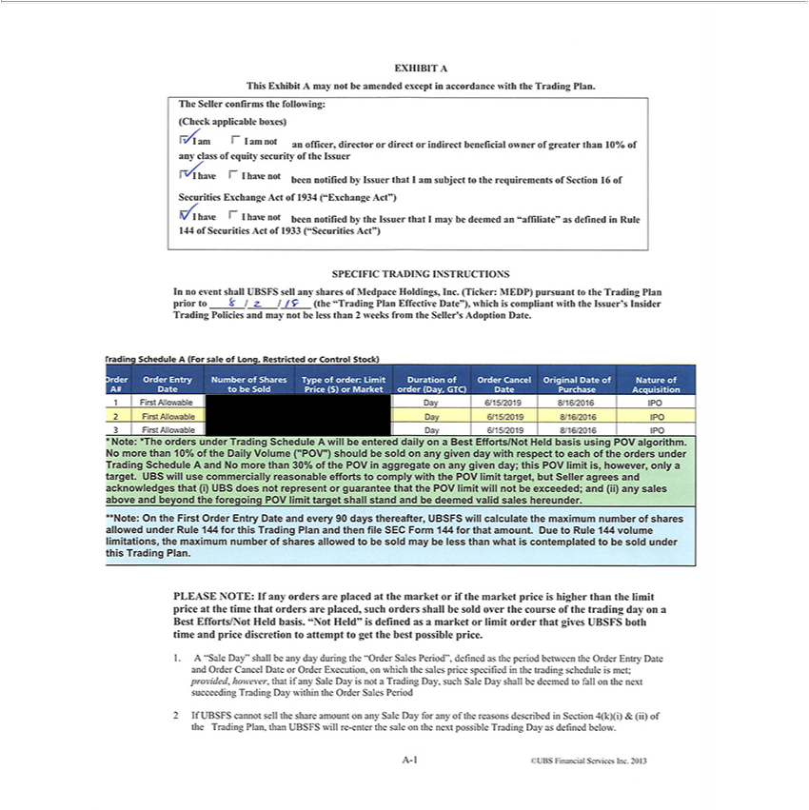

This Exhibit A may not be amended except in accordance with the Trading Plan. The Seller confirms the following: (Check applicable boxes) A am I am not an officer, director or direct or indirect
beneficial owner of greater than 10% of any class of equity security of the | I have i I have not been notjfie(j jjy |ssuer that I am subject to the requirements of Section 16 of Securities Exchange Act
of 1934 (“Exchange Act”) V I have I have not been notified by the Issuer thatIssuermay be deemed an “affiliate” as defined in Rule 144 of Securities Act of 1933 (“Securities Act”) SPECIFIC TRADING
INSTRUCTIONS no event shall UBSFS sell any shares of Medpace Holdings, Inc. (Ticker: MEDP) pursuant to the Trading Plan prior to 8/2/18 (the “Trading Plan Effective Date”), which is compliant
with the Issuer’ Insider Trading Policies and may not be less than 2 weeks from the Seller’s Adoption Date. trading Schedule A (For sale of Long, Restricted or Control Stock) order A# Order Entry Date
Number of Shares to be Sold Type of order: Limit Price ($) or Market Duration of order (Day, GTC) Order Cancel Date Original Date of Purchase Nature of |  |  | 1 First | Day 6/15/2019
8/16/2016 IPO 2 First Allowable Day 6/15/2019 8/16/2016 IPO 3 First Allowable Day 6/15/2019 8/16/2016 IPO *Note: *The orders under Trading ScheduleAcquisitionwillbeentered dailyAllowableonBest Efforts/Not
basis using POV algorithm. No more than 10% of the Daily Volume (“POV”) should be sold on any given day with respect to each of the orders under Trading Schedule A and No more than 30% of
HeldPOV in aggregate on any given day; this POV limit is, however, only a target. UBS will use commercially reasonable efforts to comply with the POV limit target, but Seller agrees and acknowledges
that (i) UBS does not represent or guarantee that the POV limit will not be exceeded; and (ii) any sales above and beyond the foregoing POV limit target shall stand and be deemed valid sales hereunder.
**Note: On the First Order Entry Date and every 90 days thereafter, UBSFS will calculate the maximum |  | of shares allowed under Rule 144 for this Trading Plan and then file SEC Form 144 for
that amount. Due to Rule 144 volume limitations, the maximum number of shares allowed to be sold maynumberless than what is contemplated to be sold under this Trading Plan. PLEASE NOTE: If any _{orders} are placed at the market or if the market price is higher than the limit price at the time that orders are placed, such orders shall be sold over the course of the trading day on a Best Efforts/Not Held _{Period”,}bas.“Not Held” is defined as a market or limit order that gives UBSFS both time and price discretion to attempt to get the best possible price. A “Sale Day” shall be any day during the “Order Sales
defined as the period between the Order Entry Date and Order Cancel Date or Order Execution, on which the sales price specified in the trading schedule is met; provided, however, th^{Day}t if any
Sale Day is not a Trading Day, such Sale Day shall be deemed to fall on the next succeeding Trading Day within the Order Sales Period 2 If UBSFS cannot sell the share amount on any Sale for any of the reasons described in Section 4(k)(i) & (ii) of the Trading Plan, than UBSFS will re-enter the sale on the next possible Trading Day as defined below.

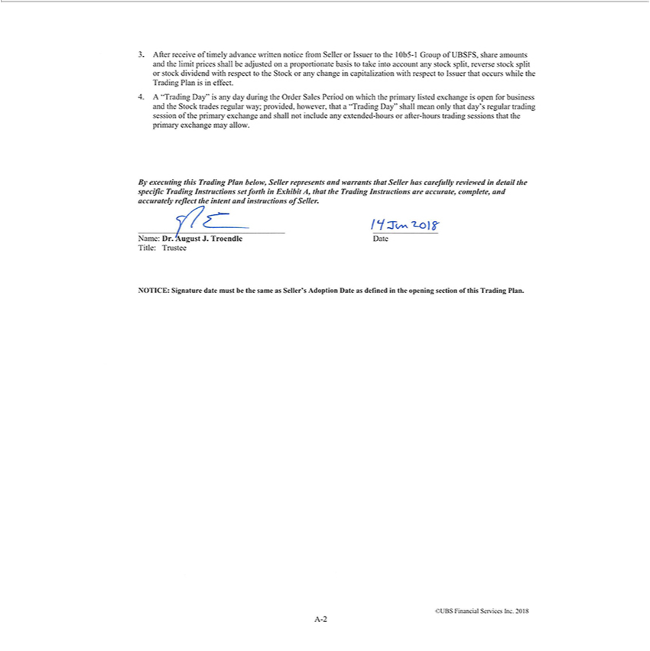

After receive of timely advance written notice from Seller or Issuer^{Stock}the 10b5-1 Group of UBSFS, share amounts and the limit prices shall be adjusted on a proportionate basis to take into account any
stock split, reverse stock split or stock dividend with respect to the or any change in capitalization with respect to Issuer that occurs while the Trading Plan is in effect. A “Trading Day” is any day during the Order Sales Period on which the primary listed exchange is open for business and the Stock trades regular way; provided, however, that^{allow}“Trading Day” shall mean only that day’s regular

^{this}rading session of the primary exchange and shall not include any extended-hours or after-hours trading sessions that the primary exchange may . [GRAPHIC APPEARS HERE] Date By executing Trading Plan below, Seller represents and warrants that Seller has carefully reviewed in detail the specific Trading Instructions set forth in Exhibit A, that the Trading Instructions are accurate,
complete, and accurately reflect the intent and instructions of Seller. [GRAPHIC APPEARS HERE] Title: Trustee NOTICE: Signature date must be the same as Seller’s Adoption Date as defined in the opening section of this Trading Plan.

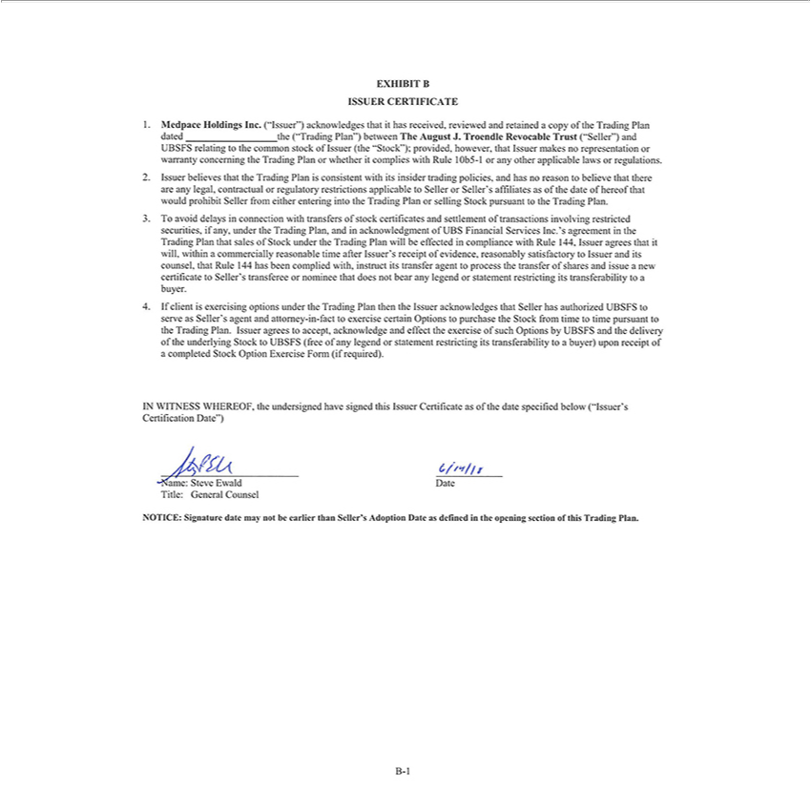

ISSUER CERTIFICATE Mcdpace Holdings Inc. (“Issuer”) acknowledges that it has received, reviewed and retained a copy of the Trading Plan dated the (“Trading Plan”) between The August J.
Troendle Revocable Trust (“Seller”) and UBSFS relating to the common stock of Issuer (the “Stock”); provided, however, that Issuer makes no representation or warranty concerning the Trading Plan or
whether it complies with Rule 10b5-1 or any other applicable laws or regulations. Issuer believes that the Trading Plan is consistent with its insider trading policies, and has no reason to believe that there
are any legal, contractual or |  | restrictions applicable to Seller or Seller’ affiliates as of the date of |  | that would prohibit Seller from either entering into the Trading Plan or selling Stock
pursuant to the Trading Plan.regulatoryTavoid delays in connection with transfers of stock certificates and settlementhereoftransactions involving restricted securities, if any, under the Trading Plan, and in
acknowledgment of UBS Financial |  |  | Inc.’s agreement in the Trading Plan that sales of Stock under the Trading Plan will be effected in compliance with Rule 144, Issuer agrees that it will, within a
commercially | time after Issuer’ |  | receipt of evidence, reasonably satisfactory to Issuer and its counsel, that Rule 144 has been complied with, instruct its transfer agent to process the transfer of
shares and issuereasonablenewcertificate to ServicesSeller’ |  |  | transferee or nominee that does not bear any legend statement restricting its transferability to buyer. If client is exercising options under the Trading Plan
then the Issuer acknowledges that Seller has authorized UBSFS to serve as Seller’s agent and attorney-in-fact to exercise certain Options to purchase the Stock from time to time pursuant to the Trading
Plan. Issuer | to accept, acknowledge and effect the exercise of such Options by UBSFS and the delivery of the underlying Stock to UBSFS (free of any legend or statement restricting its
transferability to | buyer) upon receipt of a completed Stock Option Exercise Form (if required). IN WITNESS WHEREOF, the undersigned have signed this Issuer Certificate as of the date specified
below (“Issuer’agreesCertification Date”) Date Name: Steve Ewald Title: General Counsel NOTICE: Signature date may not be earlier than Seller’s Adoption Date as defined in the opening section of this Trading Plan.

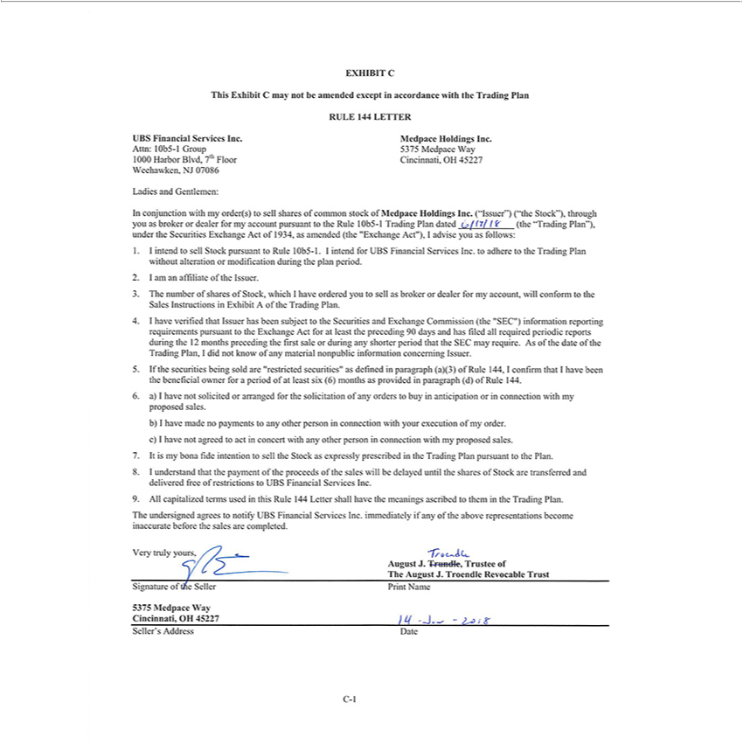

This Exhibit C may not be amended except in accordance with the Trading Plan RULE 144 LETTER UBS Financial Services Inc. Medpace Holdings Inc. Attn: 10b5-1 Group 5375 Medpace Way 1000
Harbor Blvd, 7lh Floor Cincinnati, OH 45227 Weehawken, NJ 07086 Ladies and Gentlemen: In |  |  |  | with my order(s) to sell shares of common stock of Medpace Holdings Inc. (“Issuer”) (“the
Stock”), through you as broker or dealer for my account pursuant to the Rule 10b5- Trading Planconjunctiondated/(7/ It (the “Trading Plan”), under the Securities Exchange Act of 1934, as amended (the
“Exchange Act”), 1 advise you as follows: intend to sell Stock pursuant |  |  | Rule 10b5-l. 1 intend for UBS Financial Services Inc. to adhere to the Trading Plan without alteration or modification during
the plan period. I am an affiliate of the Issuer. The number of shares of Stock, which I have ordered you to sell as broker dealer for my account, will conform to the Sales Instructions in Exhibit A of the
Trading Plan. I have verified that Issuer has been subject to the Securities and Exchange Commission (the “SEC”) information reporting requirements pursuant to the Exchange Act for at least the
preceding 90 days and has filed all required periodic reports during the 12 months preceding the first sale or during any shorter period that the SEC may require. As of the date of the Trading Plan, I did
not know of any | nonpublic information | Issuer. If the securities being sold are “restricted securities” as defined in paragraph (a)(3) of Rule 144,I confirm that I have been the beneficial
owner for periodmaterialofleast six (6) months as providedconcerningparagraph (d) of Rule 144. a) I have not solicited or arranged for the solicitation of any orders to buy in anticipation or in connection with my
proposed sales. I have made no payments to any other person in connection with your execution of my order. I have not agreed to act in concert with any other person in connection with my proposed
ales. It is my bona fide intention to sell the Stock as expressly prescribed |  |  | the Trading Plan pursuant to the Plan. I understand that the payment of the proceeds of the sales will be delayed until the
shares of Stock are transferred and delivered free of restrictions to UBS Financial Services Inc. All capitalized terms used in this Rule 144 Letter shall have the meanings ascribed to them in the Trading Plan. The undersigned agrees to notify UBS Financial Services Inc. immediately if any of the above representations become August J. Trundle, Trustee of The August J. Troendle Revocable Trust [GRAPHIC APPEARS HERE] Very truly yours, inaccurate before the sales are completed. Seller’s Address Date C-1

Signature of t/e Seller Print Name 5375 Medpace Way Cincinnati, OH 45227 14—jun 2018

